1. RabbitMQ: It is **message broker or intelligent message bus**.  
   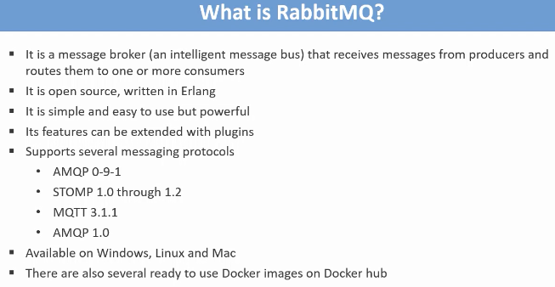
2. Here is the general architecture of **Rabbit MQ Messaging System**.
3. 